FD&C Dye Content of Popular Beverages

Department of Chemistry Honors Thesis

by

**Rachel Haislip**

University of Central Arkansas

Conway, Arkansas 72035

Spring 2018

This thesis is presented as partial fulfillment of requirements

for a B.S. degree with honors in Chemistry.

Thesis Committee:

Department Chair: ___________________________________

Patrick J. Desrochers, Ph.D.

Professor of Chemistry

Adviser: ___________________________________

Robert Mauldin, Ph.D.

Professor of Chemistry

Reader: ___________________________________

Nathan Meredith, Ph.D.

Assistant Professor of Chemistry

Reader: ___________________________________

Lei Yang, Ph.D.

Associate Professor of Chemistry

Table of Contents

Introduction 3

Experimental 8

Results and Discussion 12

References………………………………………………….……...….27

# ****Introduction****

The use of additives to alter food’s appearance goes back to the first century C.E. when wine merchants used smoke and aloe extract to improve the color of the wine, possibly to fool customers into believing the wine was better quality than it really was. This practice of using additives to deceive consumers continued for hundreds of years with milk tinted yellow to hide that it was watered-down and bread dyed white to hide the use of low quality flour.1 Many of these colorants were quite toxic, with lead chromate and lead oxide being used for the tasks mentioned above, respectively.1 Even tea was cut with iron filings, clay, and copper sulfate that would make the color more intense to hide the fact that the actual amount of tea being purchased was much less than advertised.2 However, consumers were not completely blind to this practice.

As far back as 1292, “pure food laws” existed to hold manufacturers and sellers accountable if their products were found to be adulterated.2 In 1856, the first synthetic organic dye was accidentally created by William Perkin – a discovery that led to the creation of many more of these “coal-tar” dyes (so called because of the material from which they were originally extracted) whose use became widespread in the food industry.1 These organic dyes were less dangerous alternatives to the heavy metal inorganic compounds used previously, but their safety is still not certain. In 1906, the Pure Food and Drug Act was passed in the United States, finally regulating which of these coal-tar dyes were considered safe for use in food and drugs.1 It is clear that for most of history, humans have had a desire to know what is in their food.

Perhaps now is the time, in our health-centric society, when what is in our food is most important to us. We are no longer hunter-gatherers, taking whatever we can find. We are faced with seemingly endless choices of what to eat, and with all these choices we want to be certain we are making the right ones.

Making the right decisions about food is especially important when it comes to our children. One topic that has recently gotten much attention is artificial food dyes3. These dyes are used to add color to an otherwise colorless product, to restore the color of a product whose natural color was lost through processing, or to standardize the appearance of products when the natural color may vary.4 Artificial dyes are used because they are cheaper and more stable than their naturally derived counterparts. There are currently seven major Food, Drug, and Cosmetic (FD&C) dyes approved for use in the United States, with the four most common being Red 40 (“Allura Red”), Blue 1 (“Brilliant Blue”), Yellow 5 (“Tartrazine”), and Yellow 6 (“Sunset Yellow”).

Countries around the world are concerned with the safety of these dyes. Red 40 is banned in Denmark, Belgium, France, Switzerland, and Sweden. Yellow 5 is banned in Norway.5 The European Union requires any product containing Yellow 5 to carry a label warning consumers about possible allergic reactions.5

A study has shown that some food additives may have adverse effects on children’s behavioral development with certain artificial food dyes linked to hyperactivity and attention deficit.6 Red 40 has the potential to cause allergic reactions in those who are genetically predisposed. Yellow 5 has been implicated in attention deficit problems in children and allergic reactions among asthmatics and those with an aspirin intolerance.5 Blue 1 has been linked to allergic reactions in those with pre-existing asthma.5 Symptoms of allergic reactions from all three of these dyes include skin rashes, stomach cramps, and difficulty breathing.

Knowing this, parents may want their children to avoid consuming anything containing artificial food dyes, but this may prove difficult as the majority of food and beverages marketed to children contain at least one artificial dye.7 These allergic reactions are happening with higher frequency, perhaps because our exposure to these dyes has increased as more and more manufacturers include them among their ingredients. In fact, in the United States, artificial food dye consumption has increased five-fold since 1950.7

These claims of allergic reactions and hyperactivity have been investigated by the Food and Drug Administration (FDA); however, the evidence has not been strong enough to merit any change in the “generally recognized as safe” status of any of these dyes as an approved artificial food dye. The FDA claims that any increase in hyperactivity can be attributed to “a unique intolerance to these substances and not to any inherent neurotoxic properties.”8 It should also be noted that these reactions with Yellow 5 are only seen in 0.12% of the general population.5

Currently, food manufacturers are required to list any artificial dyes their product contains, but they are not required to list the quantity. This quantity could be the deciding factor when purchasing one product over another. The FDA recommends that people consume no more than 7 milligrams of Red 40, 6 milligrams of Blue 1, and 7.5 milligrams of Yellow 5 per kilogram of body weight per day.9 Therefore, if the product has a high amount of any of these dyes per serving, the consumer may be less likely to buy it. However, since manufacturers do not have to report the *amount* of dye present, the consumer has no way of knowing if the product is safe.

Less than one milligram of these dyes can produce an intense color, so if the dye is used to color food, a very small amount should suffice. The amount of food dyes in most products is probably not high enough to cause any adverse health effect in adults, but the dose needed to cause adverse health effects in children may be much smaller.9 Because of this possibility, this study is focused on determining the quantities of Red 40, Blue 1, and Yellow 5 in products commonly consumed by children using UV-Visible absorbance spectroscopy. Yellow 6 was not studied because spectral overlap between Yellow 5 and Yellow 6 is so great that it is not reliably possible to tell the two dyes apart using this experimental technique. Some properties of these dyes are listed in Table 1. Chemical structures for Red 40, Blue 1, and Yellow 5 are shown in Figure 1.

Beverages and liquid medicines contain the highest concentration of artificial food colorants (AFCs) and were therefore the most appealing samples for analysis considering the experimental approach. Solids containing AFCs were not used as samples because getting the dye into an aqueous state did not yield transparent enough solutions for UV-Visible analysis. A list of samples and their serving sizes can be found in Table 2.

**Table 1. Physical properties of Red 40, Blue 1, and Yellow 5.**

|  |  |  |  |
| --- | --- | --- | --- |
| FD&C Dye | Molecular Weight (g·mol-1) | λmax (nm) | Molar absorptivity (L·mol-1· cm-1) |
| Red 40 | 496.42 | 505 | 2.50 X 104 |
| Blue 1 | 791.84 | 630 | 1.05 X 105 |
| Yellow 5 | 534.30 | 429 | 2.12 X 104 |

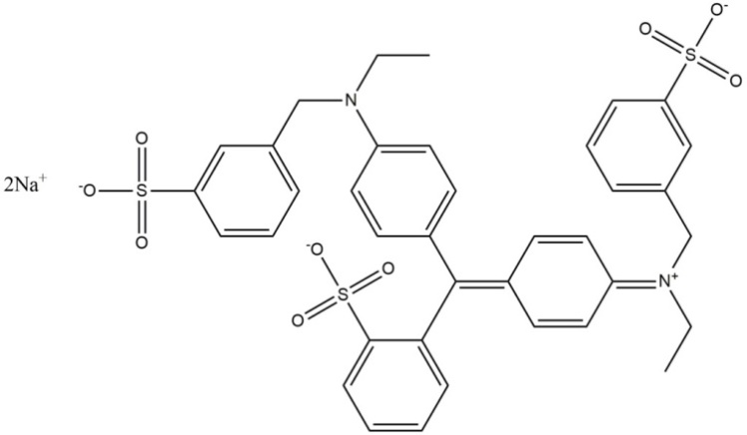 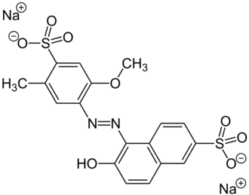 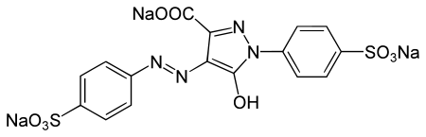

Figure 1. Structures of Blue 1 (top left), Red 40 (top right), and Yellow 5 (bottom center). The highly conjugated dyes allow for the absorption of light in the visible range The least conjugated system absorbs the shortest wavelength of light (Yellow 5 at 429 nm) and the system with the highest conjugation absorbs light of the longest wavelength (Blue 1 at 630 nm).

**Table 2. List of sample beverages and their servings sizes**

|  |  |
| --- | --- |
| **Sample** | **Serving Size (mL)** |
| Kool Aid Jammers Grape | 177 |
| Gatorade G2 Grape | 355 |
| Gatorade G2 Fruit Punch | 355 |
| Gatorade Tropical Cooler | 355 |
| Gatorade Icy Charge | 355 |
| Powerade Twisted Blackberry | 360 |
| Powerade Fruit Punch | 360 |
| Powerade Lemon Lime | 360 |
| Powerade Mountain Berry Blast | 360 |
| Kool Aid Bursts Fruit Punch | 200 |
| Kool Aid Bursts Grape | 200 |
| Kool Aid Bursts Cherry | 200 |
| Kool Aid Grape Powder | 237 |
| Kool Aid Tropical Punch Powder | 237 |
| Hawaiian Punch Fruit Juicy Red | 296 |
| Mountain Dew | 591 |
| Pedialyte Grape | 237 |
| Pedialyte Strawberry | 360 |
| Nyquil Children’s Cold & Cough Cherry | 15 |
| V8 Splash Strawberry Lemonade | 363 |

# Experimental

Calibration curves for Red 40, Blue 1, and Yellow 5 were constructed by creating a stock of each dye and diluting each stock according to the dilution schemes shown in Tables 3-5. Each standard was analyzed using a Cary Scan 50 UV-Visible spectrophotometer. The absorbance of each standard at the dye’s wavelength of maximum absorbance (λmax) was measured using deionized water as a blank. The data were compiled into a calibration curve for each dye. The slopes of these calibration curves were used as the molar absorptivities for analysis since the pathlength of the cell was 1.00 cm and the concentration was in molarity as per the Beer-Lambert Law discussed on page 20.

The dyes were separated from the samples by pulling the samples through a Supelclean LC-18 SepPak. The SepPak was cleaned with HPLC-grade methanol and then conditioned with a 1% acetic acid solution. One drop of this acetic acid solution was added to 3 mL of each sample to ensure the dyes would adsorb to the packing. The solution that came off the packing was analyzed using the UV-Visible spectrophotometer to see if anything else in the solution absorbed at the dye in question’s λmax. If the sample contained no component other than the dye that absorbed at the λmax, the sample was analyzed using the UV-vis without any preparation. If a sample contained compounds other than the three dyes in question that absorb at the λmax of any of the dyes, the absorbance of the other compound was subtracted from the absorbance of the sample before any calculations were done.

The Kool-Aid Bursts (Cherry, Grape, and Fruit Punch), Gatorade Fruit Punch, Gatorade Tropical Cooler, Hawaiian Punch, the Powerades (Blackberry, Mountain Berry, Lemon Lime, and Fruit Punch), the powdered Kool Aids (Grape and Tropical Punch), and the Nyquil had an absorbance too high for the spectrophotometer to measure. This absorbance was lowered by performing a 25-fold dilution on the Kool Aid Bursts (Cherry, Grape, and Fruit Punch), the G2 Fruit Punch, the Hawaiian Punch, the powdered Kool Aids (Tropical Punch and Grape), two Powerades (Blackberry and Fruit Punch), and the Nyquil. A 12.5-fold dilution was performed on the remaining Powerades (Lemon Lime and Mountain Berry Blast), and Gatorade Tropical Cooler. Mountain Dew was decarbonated prior to analysis by placing a beaker containing the liquid and a magnetic stir bar on a stir plate and allowing the beverage to be stirred for several minutes.

**Table 3. Dilution scheme for Red 40 calibration curve.**

|  |  |  |  |
| --- | --- | --- | --- |
| Concentration of Stock (M) | Volume of Stock (mL) | Final volume (mL) | Final Concentration (M) |
| 1.9995 X 10-4 | 0.1 | 50 | 3.99 X 10-9 |
| 1.9995 X 10-4 | 0.5 | 50 | 4.00X 10-7 |
| 1.9995 X 10-4 | 1 | 50 | 4.00 X 10-6 |
| 1.9995 X 10-4 | 2 | 50 | 8.00 X 10-6 |
| 1.9995 X 10-4 | 4 | 50 | 1.60 X 10-5 |
| 1.9995 X 10-4 | 5 | 50 | 2.00 X 10-5 |
| 1.9995 X 10-4 | 10 | 50 | 3.99 X 10-5 |
| 1.9995 X 10-4 | 12 | 50 | 4.79 X 10-5 |
| 1.9995 X 10-4 | 15 | 50 | 5.99 X 10-5 |
| 1.9995 X 10-4 | 20 | 50 | 7.99 X 10-5 |

**Table 4. Dilution scheme for Blue 1 calibration curve.**

|  |  |  |  |
| --- | --- | --- | --- |
| Concentration of Stock (M) | Volume of Stock (mL) | Final volume (mL) | Final Concentration (M) |
| 2.01 X 10-5 | 0.1 | 50 | 4.02 X 10-8 |
| 2.01 X 10-5 | 0.5 | 50 | 2.01 X 10-7 |
| 2.01 X 10-5 | 1 | 50 | 4.02 X 10-7 |
| 2.01 X 10-5 | 2 | 50 | 8.04 X 10-7 |
| 2.01 X 10-5 | 3 | 50 | 1.21 X 10-6 |
| 2.01 X 10-5 | 4 | 50 | 1.61 X 10-6 |
| 2.01 X 10-5 | 5 | 50 | 2.01 X 10-6 |
| 2.01 X 10-5 | 10 | 50 | 4.02 X 10-6 |
| 2.01 X 10-5 | 15 | 50 | 6.03 X 10-6 |
| 2.01 X 10-5 | 25 | 50 | 1.00 X 10-5 |

**Table 5. Dilution scheme for Yellow 5 calibration curve.**

|  |  |  |  |
| --- | --- | --- | --- |
| Concentration of Stock (M) | Volume of Stock (mL) | Final volume (mL) | Final Concentration (M) |
| 1.01 X 10-5 | 1 | 50 | 2.02 X 10-7 |
| 1.01 X 10-5 | 2 | 50 | 4.04 X 10-7 |
| 1.01 X 10-5 | 3 | 50 | 6.06 X 10-7 |
| 1.01 X 10-5 | 4 | 50 | 8.08 X 10-7 |
| 1.01 X 10-5 | 5 | 50 | 1.01 X 10-6 |
| 1.01 X 10-5 | 10 | 50 | 2.02 X 10-6 |
| 1.01 X 10-5 | 15 | 50 | 3.03 X 10-6 |
| 1.01 X 10-5 | 20 | 50 | 4.04 X 10-6 |
| 1.01 X 10-5 | 25 | 50 | 5.05 X 10-6 |
| 1.01 X 10-5 | 50 | 50 | 1.01 X 10-5 |

The absorbance at the λmax for each dye was recorded and normalized to 1.00 to account for any spectral overlap between the dyes, as absorbances are additive and in a sample containing more than one dye, the absorbance of one dye may affect the absorbance of another dye (Figure 2). To normalize these values, the absorbances of each dye at the λmax of each dye were recorded. The normalized values are shown in Table 6. How these values were calculated is shown in Supporting Information 1.

Equations for adjusting the absorbance to account for these overlaps can be written using the normalized absorbance values:

$A_{B1}=A_{630}-{0.0462A}_{R40}$ (1)

$A_{R40}=A_{505}-{0.00670A}_{B1}$ (2)

where A505 and A630 are the total absorbances at 505 nm and 630 nm, respectively; and AB1 and AR40 are the absorbances at the λmax in question due exclusively to Yellow 5 and Red 40, respectively, and ${0.0462A}_{R40}$ is the absorbance of the sample at 505 nm multiplied by the normalized absorbance value for this overlap.10 Equation 1 can be substituted into Equation 2 and vice versa to solve for the absorbance due exclusively to one dye. These calculations were applied to any sample containing more than one dye.

While there was relatively low risk for all chemicals involved in this experiment, safety glasses were worn. The 1% acetic acid solution was made using glacial acetic acid in a fume hood while wearing nitrile gloves. The HPCL-grade methanol was also handled using gloves.

**Table 6. Normalized Absorbance Values for Dyes.**

|  |  |  |  |
| --- | --- | --- | --- |
|  | 630 nm | 505 nm | 429 nm |
| Blue 1 | 1.00 | 0.00670 | 0.0219 |
| Red 40 | 0.0462 | 1.00 | 0.291 |
| Yellow 5 | 0.00604 | 0.00 | 1.00 |

**Figure 2.** Overlap of absorbances of Yellow 5 (left), Red 40 (center), and Blue 1 (right). There is significant overlap between Red 40 and Yellow 5.

**Results**

A calibration curve for each dye can be found in Figure 3. The UV-Visible absorption spectrum for each sample can be seen in Figures 4-23. Only V8 Splash appeared to contain something other than an AFC that absorbed significantly at any wavelength. For this reason, this sample was not used in the rest of this study. Each sample’s absorbance can be found in Table 7.

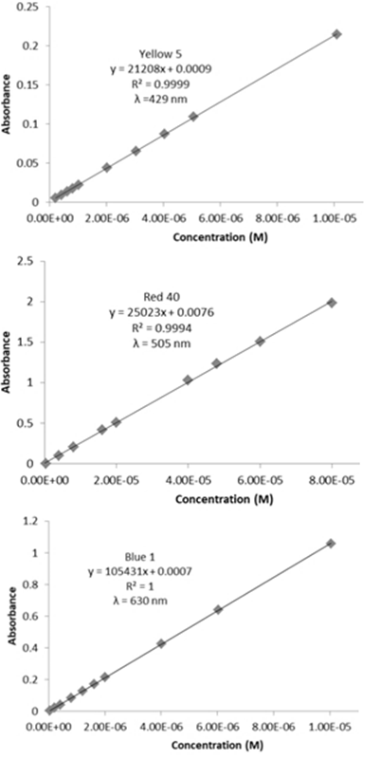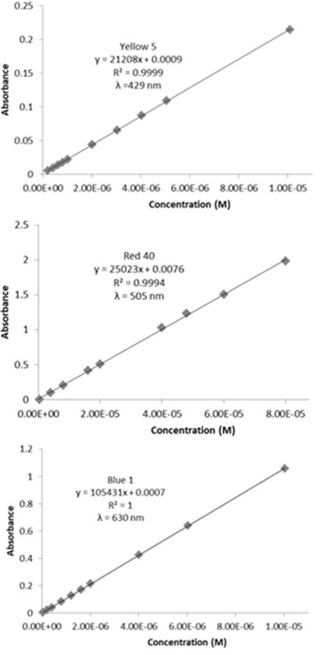

**Figure 3.** Calibration Curves for Yellow 5, Red 40, and Blue 1.

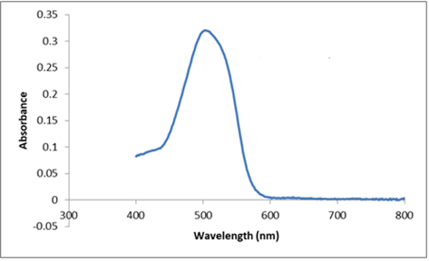

**Figure 4.** UV-Visible spectrum for Kool Aid Bursts Cherry.

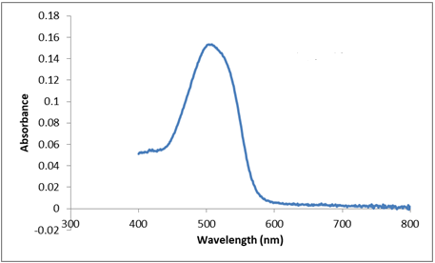

**Figure 5.** UV-Visible spectrum for Kool Aid Bursts Fruit Punch.

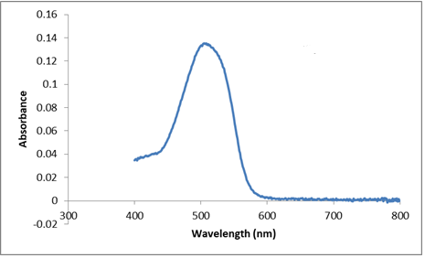

**Figure 6**. UV-Visible spectrum for Powdered Kool Aid Tropical Punch.

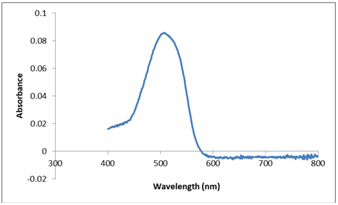

**Figure 7.** UV-Visible spectrum for Gatorade G2 Fruit Punch.

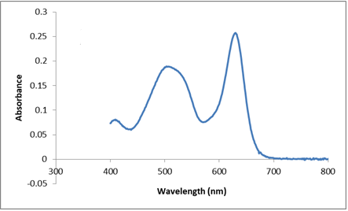

**Figure 8.** UV-Visible spectrum for Gatorade G2 Grape.

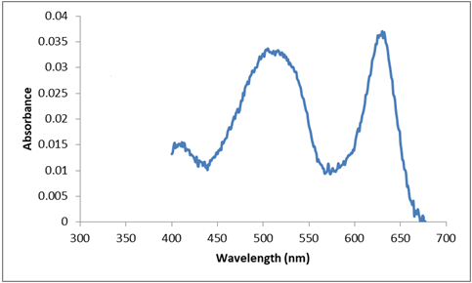

**Figure 9.** UV-Visible spectrum for Kool Aid Jammers Grape.

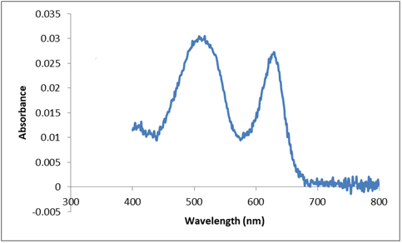

**Figure 10.** UV-Visible spectrum for Powdered Kool Aid Grape.

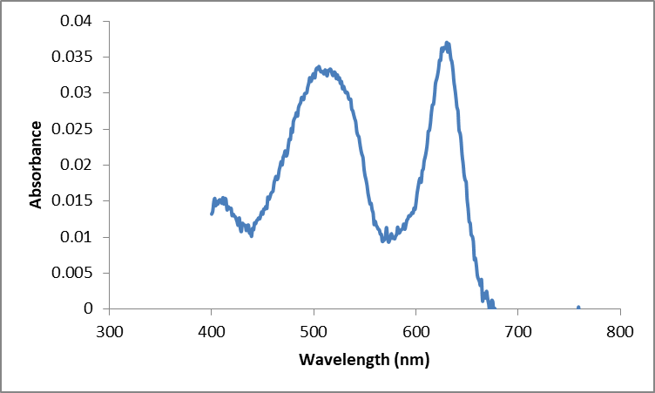

**Figure 11.** UV-Visible spectrum for Kool Aid Bursts Grape.

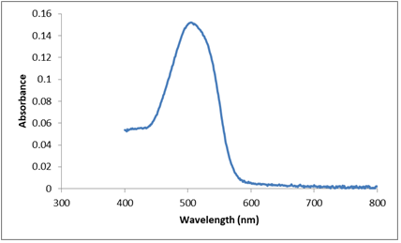

**Figure 12.** UV-Visible spectrum for Hawaiian Punch.

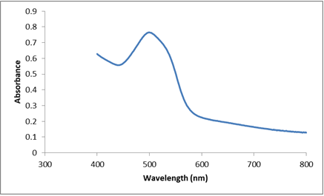

**Figure 13.** UV-Visible absorption spectrum for V8 Splash. The fact that the baseline slopes upward toward smaller wavelengths indicates that V8 Splash contains something else that is interfering with this analysis, likely scattering of incident light by particulates in the added fruit juice.

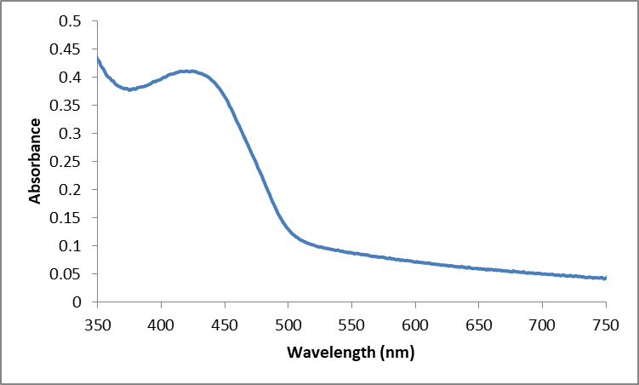

**Figure 14.** UV-Visible spectrum for Mountain Dew. The baseline slopes upwards, indicating some unknown interfering with the absorbance of Yellow 5.

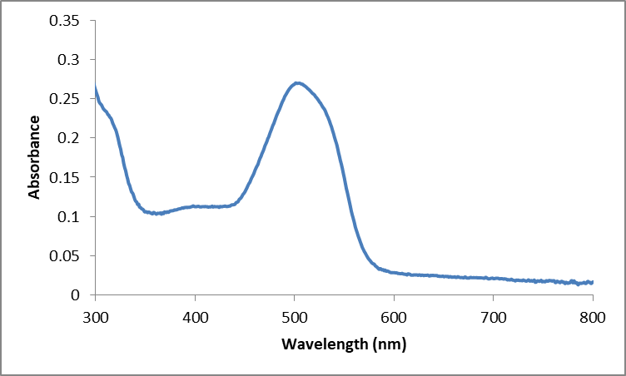

**Figure 15.** UV-Visible spectrum for Powerade Fruit Punch.

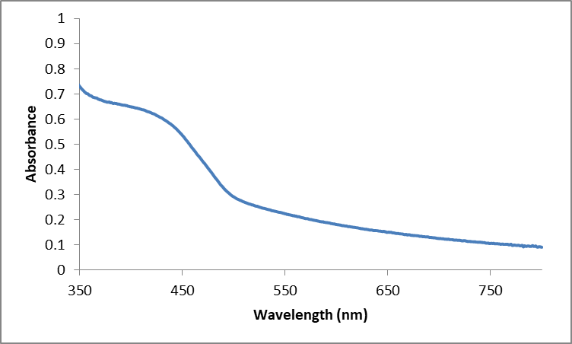

**Figure 16.** UV-Visible spectrum for Powerade Lemon Lime. The baseline slopes upwards, indicating some unknown interfering with the absorbance of Yellow 5.

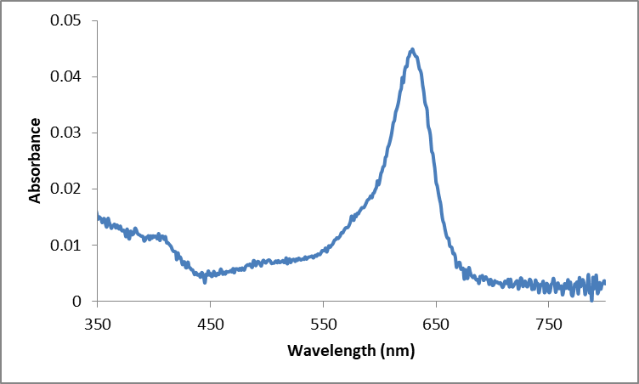

**Figure 17.** UV-Visible spectrum for Powerade Mountain Berry Blast.

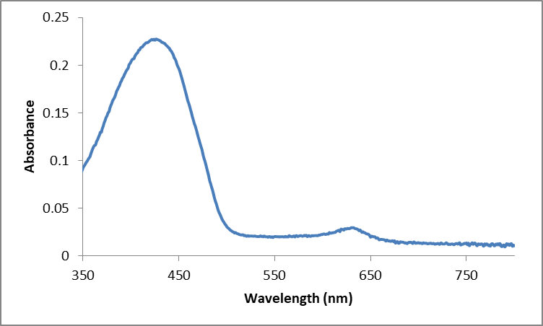

**Figure 18.** UV-Visible spectrum for Powerade Tropical Cooler.

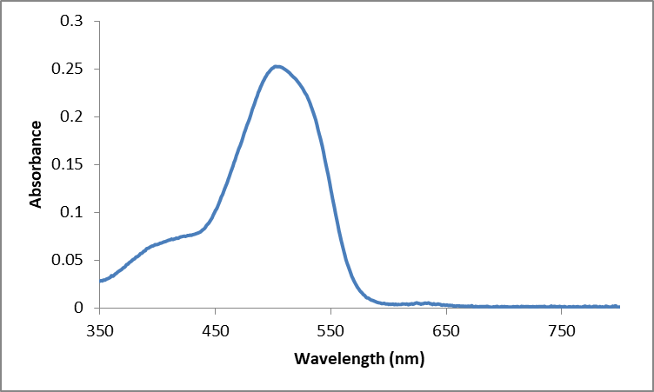

**Figure 19.** UV-Visible spectrum for Powerade Twisted Blackberry.

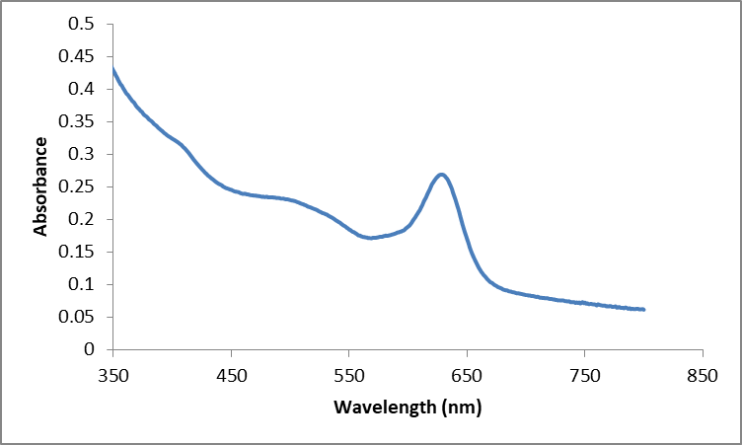

**Figure 20.** UV-Visible spectrum for Gatorade Icy Charge.

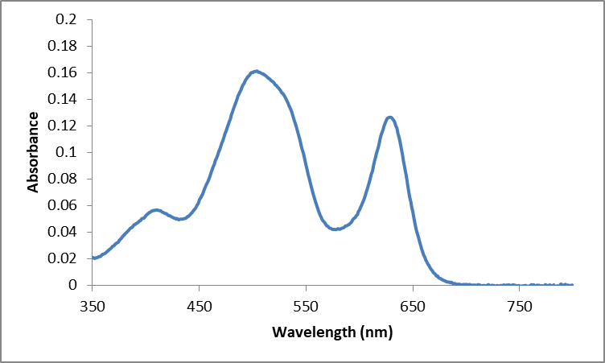

**Figure 21.** UV-Visible spectrum for Pedialyte Grape.

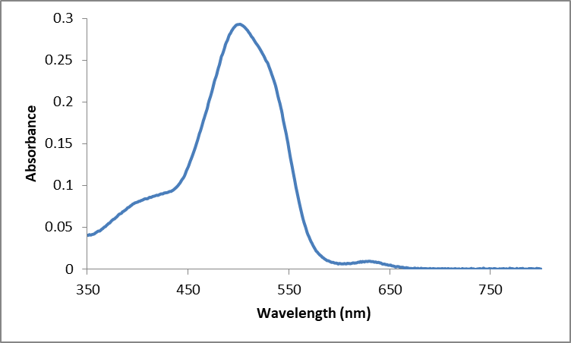

**Figure 22.** UV-Visible spectrum for Pedialyte Strawberry.

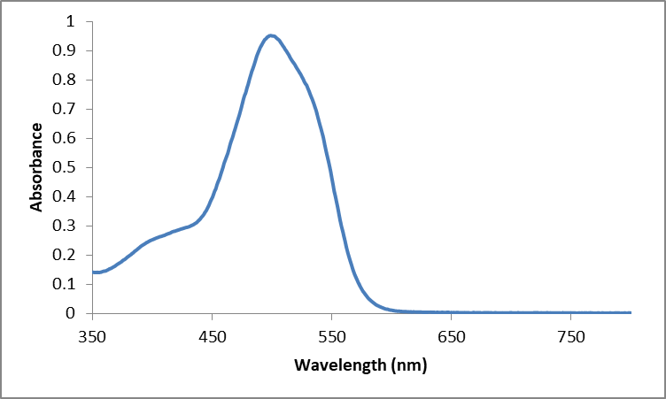

**Figure 23.** UV-Visible spectrum for Nyquil Children’s Cold & Cough Cherry.

To determine the concentration of each dye in each product, the Beer-Lambert Law was used:

$$A=εbc$$

where A is the absorbance at the λmax of the dye, ε is the molar absorptivity, b is the pathlength, and c is the concentration. The pathlength in this experiment was 1 cm. A sample calculation for determining the mass of Red 40 in Kool-Aid Bursts Cherry is shown in Supporting Information 2. Similar calculations were done for each sample. The results of these calculations are shown in Table 8 and Table 9.

**Table 7. Absorbances at the λmax for each dye after correcting for overlap.**

|  |  |  |  |
| --- | --- | --- | --- |
| **Sample** | ABlue 1 | ARed 40 | AYellow 5 |
| Kool Aid Jammers Grape | 0.0334 | 0.0320 | - |
| Gatorade G2 Grape | 0.2555 | 0.1754 | - |
| Gatorade G2 Fruit Punch | - | 0.0854 | - |
| Gatorade Tropical Cooler | 0.0274 | - | 0.2258 |
| Gatorade Icy Charge | 0.2684 | - | - |
| Powerade Twisted Blackberry | 0.0023 | 0.2523 | - |
| Powerade Fruit Punch | - | 0.2698 | - |
| Powerade Lemon Lime | - | - | 0.6063 |
| Powerade Mountain Berry Blast | 0.0444 | - | - |
| Kool Aid Bursts Fruit Punch | - | 0.1528 | - |
| Kool Aid Bursts Grape | 0.0334 | 0.0320 | - |
| Kool Aid Bursts Cherry | - | 0.3198 | - |
| Kool Aid Grape Powder | 0.0269 | 0.0280 | - |
| Kool Aid Tropical Punch Powder | - | 0.1353 | - |
| Hawaiian Punch Fruit Juicy Red | - | 0.1520 | - |
| Mountain Dew | - | - | 0.4069 |
| Pedialyte Grape | 0.1247 | 0.1543 | - |
| Pedialyte Strawberry | 0.0068 | 0.2902 | - |
| Nyquil Children’s Cold & Cough Cherry | - | 0.9390 | - |

**Table 8. Mass of each dye in one serving of sample.**

|  |  |  |  |
| --- | --- | --- | --- |
| **Sample** | Blue 1 (mg) | Red 40 (mg) | Yellow 5 (mg) |
| Kool Aid Jammers Grape | 0.044 | 0.11 | - |
| Gatorade G2 Grape | 0.67 | 1.2 | - |
| Gatorade G2 Fruit Punch | - | 15 | - |
| Gatorade Tropical Cooler | 0.92 | - | 25 |
| Gatorade Icy Charge | 0.71 | - | - |
| Powerade Twisted Blackberry | 0.14 | 45 | - |
| Powerade Fruit Punch | - | 48 | - |
| Powerade Lemon Lime | - | - | 69 |
| Powerade Mountain Berry Blast | 3.0 | - | - |
| Kool Aid Bursts Fruit Punch | - | 15 | - |
| Kool Aid Bursts Grape | 1.3 | 3.2 | - |
| Kool Aid Bursts Cherry | - | 32 | - |
| Kool Aid Grape Powder | 1.2 | 3.3 | - |
| Kool Aid Tropical Punch Powder | - | 16 | - |
| Hawaiian Punch Fruit Juicy Red | - | 22 | - |
| Mountain Dew | - | - | 6.1 |
| Pedialyte Grape | 0.22 | 0.73 | - |
| Pedialyte Strawberry | 0.012 | 2.1 | - |
| Nyquil Children’s Cold & Cough Cherry | - | 7.0 | - |

**Table 9. Mass of each dye in 100 mL of sample.**

|  |  |  |  |
| --- | --- | --- | --- |
| **Sample** | Blue 1 (mg) | Red 40 (mg) | Yellow 5 (mg) |
| Kool Aid Jammers Grape | 0.63 | 1.6 | - |
| Gatorade G2 Grape | 0.19 | 0.35 | - |
| Gatorade G2 Fruit Punch | - | 4.2 | - |
| Gatorade Tropical Cooler | 0.26 | - | 7.1 |
| Gatorade Icy Charge | 0.20 | - | - |
|  |  |  |  |
| Powerade Twisted Blackberry | 0.043 | 13 | - |
| Powerade Fruit Punch | - | 13 | - |
| Powerade Lemon Lime | - | - | 19 |
| Powerade Mountain Berry Blast | 0.83 | - | - |
| Kool Aid Bursts Fruit Punch | - | 7.6 | - |
| Kool Aid Bursts Grape | 0.63 | 1.6 | - |
| Kool Aid Bursts Cherry | - | 16 | - |
| Kool Aid Grape Powder | 0.51 | 1.4 | - |
| Kool Aid Tropical Punch Powder | - | 6.7 | - |
| Hawaiian Punch Fruit Juicy Red | - | 7.5 | - |
| Mountain Dew | - | - | 1.0 |
| Pedialyte Grape | 0.094 | 0.31 | - |
| Pedialyte Strawberry | 0.0032 | 0.58 | - |
| Nyquil Children’s Cold & Cough Cherry | - | 47 | - |

**Discussion**

The goal of quantifying FD&C dyes in beverages popular among children was ultimately achieved. Overall, the mass of Blue 1 in all the samples is much less than masses of Red 40 and Yellow 5. This is likely due to the fact that Blue 1 has such a high molar absorptivity; therefore a very small mass of dye creates an intense color. Red 40 and Yellow 5 also have relatively high molar absorptivites, so the high amount of these dyes in some of the beverages is surprising. Quantities per serving found from this study were similar to those found in the literature.9,10 However, the studies in the literature tested multiple samples of each beverage while this study tested only one sample per beverage. Precision could have been improved with multiple samples of each beverage and medicine.

One important source of error is the fact that Yellow 5 would not adsorb to the LC-18 packing; therefore, that it was assumed nothing else in the beverage absorbed at 429 nm. If one of these beverages did contain a substance that absorbed at 429 nm, the recorded mass of Yellow 5 in that beverage would be higher than the true value. An alternative method for separating dyes from samples needs to be developed to correct for this possible error. Another possible source of error is the unknown particulates in Mountain Dew and Powerade Lemon Lime that caused the baseline to slope upward. These particulates may have cause refraction within the sample, leading to an absorbance higher than the true value.

**Conclusions**

Consumers have a right to know how much AFCs are in their food and beverages. Everything we consume has guidelines as to how much we need to maintain our health and how much we can consume without any adverse health effects. Nutrition labels report a percent daily value (%DV) for the carbohydrates, protein, fats, vitamins, and minerals in our food and beverages, but there is no %DV listed on packaging for additives like AFCs.

The FDA recommends that people consume no more than 7 milligrams of Red 40, 6 milligrams of Blue 1, and 7.5 milligrams of Yellow 5 per kilogram of body weight per day.8 So, a child weighing 27 kg, should consume no more than 189 mg of Red 40, 162 mg of Blue 1, and 202 mg of Yellow 5 in a single day. This child would receive a little more than a third of the recommended daily dose of Yellow 5 by drinking just one serving of Lemon Lime Powerade. This same child would receive more than a fourth of the recommended daily dose of Red 40 from a serving of Fruit Punch Powerade. It should be noted than some children may consume more than one serving of these drinks in a day and that beverages are not the only source of these artificial dyes a child may consume.

Should all AFCs be banned and natural dyes adopted? Why take the risk with artificial dyes when there are natural alternatives? As stated previously, artificial dyes are less expensive and more stable than their natural counterparts, and there has not been enough evidence for the FDA to completely prohibit them. More research is needed to study the effects of long-term exposure to AFCs.

In 2008, the FDA was petitioned for a complete ban on Red 3 after research linking high doses of Red 3 with cancer in rats.11 The petition stated that the partial ban instituted in 1990 violated the Delaney clause, which states that the FDA may not approve any food additive that is shown to cause cancer in humans or animals in any dose, but the FDA states that there is an exception to the clause when the concentration of the carcinogen is less than one part per million and the danger is “negligible.”12 It is for this reason that possibly carcinogenic Red 3 is still used for coloring maraschino cherries, some types of bubble gum, and other snack foods.

Many companies are already switching from artificial dyes to natural ones without the FDA’s influence. These dyes are mainly plant-based conjugated systems, some chemical structures of which are shown in Figures 24-27. Many of the natural dyes are antioxidants, so switching to natural dyes would also add this health benefit. These natural dyes are most likely safer alternatives to the synthetic organic dyes that were once lauded as the safer alternatives themselves.

“Natural” does not always mean safe, however. As with Red 40, carmine, a natural dye extracted from the red shell of the cochineal insect, can cause serious allergic reactions.13 Further research is needed to determine the safety of these dyes, and perhaps their quantities in various products would be of interest.

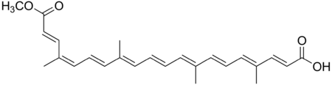

Figure 24. Structure of the chemical responsible for the red-orange coloring of annatto, a commonly used substitute for Yellow 5 and Yellow 6.

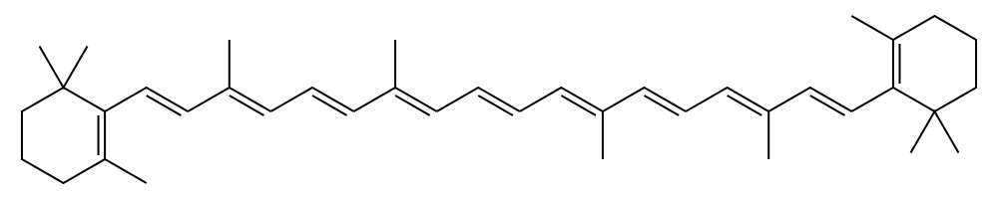

Figure 25. Structure of beta-Carotene, a yellow-orange natural colorant. It is this antioxidant and vitamin A precursor that is responsible for the orange color of carrots.

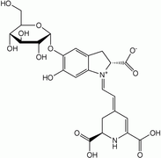 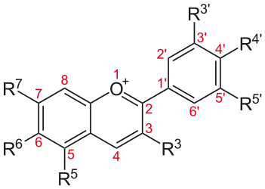

Figure 26. Structure of betanin (left) and anthocyanin (right). Betanin is a magenta dye, mainly produced from beets. Anthocyanin's color can vary from red to violet to blue depending on the R-groups and pH.

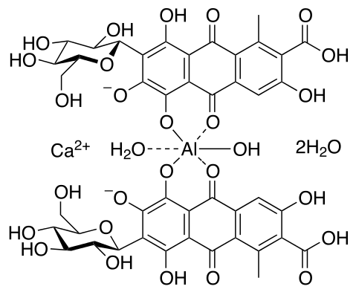

Figure 27. Structure of carmine, a red dye derived from the cochineal insect and a common alternative to Red 40.

# References

1.Vinita Sharma, Harold T. McKone, and Peter G. Markow*. Journal of Chemical Education* **2011,** *88* (1), 24-28.

2. McKone, H. T.*Bull. Hist. Chem.* **1991**, *10*,25–31

3. Bond, Annie B. EcoWatch. www.ecowatch.com/food-dye-children-behavior-2537569911.html. (accessed Apr 9, 2018)

4. Newsome, A. G., Culver, C. A., & Breemen, R. B. *J. Agric. Food Chem.* **2014,** 62(28), 6498-6511

5. Allam, K. V., Kumar G. P. *International Journal of Pharmacy and Pharmaceutical Sciences.* **2011**, 3(3), 13-21

6. Stockman, J. *Yearbook of Pediatrics*. **2009**, 94-95.

7. Batada, A., & Jacobson, M. F. *Clinical Pediatrics*. **2016,** *55*(12), 1113-1119.

8. Aungst, J. *Background Document for the Food Advisory Committee*. **2011,** http://www.fda.gov/downloads/AdvisoryCommittees/CommitteesMeetingMaterials/FoodAdvisoryCommittee/UCM248549.pdf (accessed Oct. 23, 2016)

9. Stevens, L. J., Burgess, J. R., Stochelski, M. A., & Kuczek, T. *Clinical Pediatrics*. **2013,** 53(2), 133-140.

10. Sigmann, S. B., & Wheeler, D. E. *J. Chem. Educ*. **2004**, 81(10), 1475.

11. Henkel, J. *FDA Consumer magazine.* **1993**, 27(10).

12. Merrill, Richard A.  *Annual Review of Public Health*. **1997**, 18, 313-40.

13.  Tabar, A.I.; Acero, S.; Arregui, C.; Urdánoz, M.; Quirce, S. *Anales Del Sistema Sanitario De Navarra.* **2003.** 26 (2): 65–73.

**Supporting Information**

1. Sample calculation for normalizing absorbance values

A solution of about 4 X 10-7 M Red 40 has an absorbance of 0.016333 at 429 nm, 0.056115 at 505 nm, and 0.00259 at 630 nm. Because 505 nm is the λmax of Red 40, all absorbance values were divided by the absorbance of Red 40:

|  |  |  |
| --- | --- | --- |
| 429 nm | 505 nm | 630 nm |
| $$\frac{0.016333}{0.056115}$$ | $$\frac{0.056115}{0.056115}$$ | $$\frac{0.00259}{0.056115}$$ |

So the line for Red 40 in Table 6 would read:

|  |  |  |
| --- | --- | --- |
| 429 nm | 505 nm | 630 nm |
| 0.291 | 1.00 | 0.0462 |

2. For Kool-Aid Bursts Cherry, the concentration can be found using the Beer-Lambert Law:

$$0.3198=\left(2.50 ×{10}^{4} \frac{L}{mol∙cm}\right)∙(1.00 cm)∙c$$

Solving for c, the concentration of Red 40 in Cherry Kool-Aid Bursts is 1.28 X 10-5 M Red 40; however, this is the concentration after the 25-fold dilution. The actual concentration of Red 40 in Kool-Aid Bursts Cherry is 3.19553 X 10-4 M Red 40. To find the mass of Red 40 in one hundred milliliters of Kool-Aid Bursts Cherry,

$$100 mL∙\left(3.20×{10}^{-4}\frac{mol}{1000 mL}\right)∙\left(\frac{496.42 g }{mol}\right)∙\left(\frac{1000 mg}{1 g}\right)$$

The mass of Red 40 in 100 mL of Kool-Aid Bursts Cherry is 16 mg.